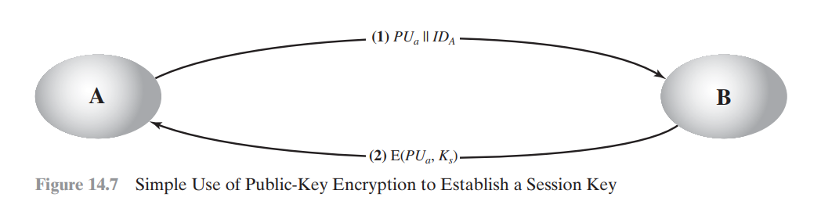

Symmetric Key Distribution using Asymmetric Encryption — Short Notes
Goal:
Securely share a secret session key (Ks) using public key encryption.

✅ Steps:
- A → B: Sends public key PUₐ and identity IDₐ
- B → A:
  - Generates session key Ks
  - Encrypts Ks with PUₐ: E(PUₐ, Ks)
  - Sends it to A
- A decrypts using private key PRₐ: D(PRₐ, E(PUₐ, Ks)) = Ks
- Now both A and B share Ks for secure communication.

✅ Advantages:
- No key exists before/after communication
- Secure against eavesdropping

❌ Weakness – Man-in-the-Middle Attack:
- Attacker E can intercept and replace keys
- Both A and B get same Ks
- E can read all messages secretly

📌 Tip for Diagram:
Label arrows as:
- (1) PUₐ || IDₐ
- (2) E(PUₐ, Ks)

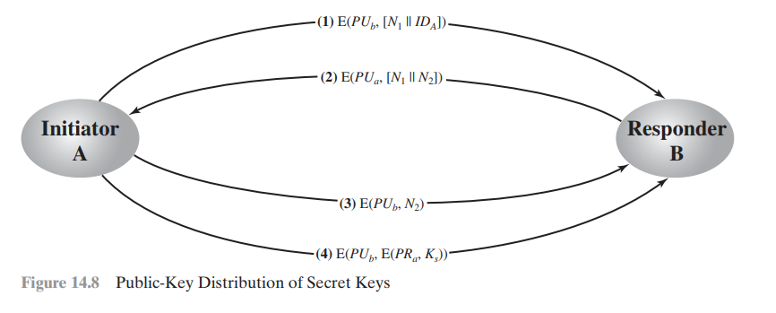

🔐 Secret Key Distribution with Confidentiality & Authentication (Short Notes)
Goal:
Securely share session key Ks between A and B, with both confidentiality and authentication.

✅ Steps:
- A → B:
E(PUb, [N1 || IDA])
→ A sends a random nonce N1 and identity, encrypted with B’s public key.
- B → A:
E(PUa, [N1 || N2])
→ B confirms receipt (by returning N1) and adds new nonce N2, encrypted with A’s public key.
- A → B:
E(PUb, N2)
→ A sends back N2, encrypted with B’s public key to prove it’s A.
- A → B:
E(PUb, E(PRa, Ks))
→ A sends session key Ks, first signed with A’s private key, then encrypted with B’s public key.

✅ Result:
- Confidentiality: Only B can decrypt with PRb
- Authentication: B verifies A using PUa
- Both share Ks safely

📝 Diagram Tip:
Draw 4 arrows with labels (1) to (4), just like shown.

Message Authentication Code (MAC)

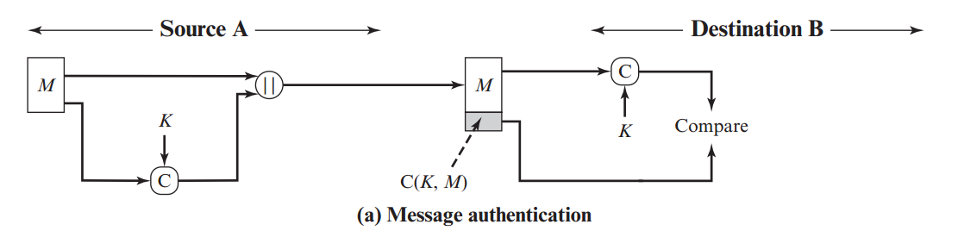

(a) Message Authentication Only
(No encryption, only authenticity check using MAC)

💡 What it shows (Summary)
Only authenticity is verified — message is not encrypted.
Used when we only want to ensure the message wasn’t modified or forged.

🧠 Steps to Memorize for Drawing

📤 Sender Side (Source A):
- Start with Message M
- Use MAC generator C with Key K → generate C(K, M)
- Combine message and MAC: [M || C(K, M)]
- Send both to receiver

📥 Receiver Side (Destination B):
- Receive M and C(K, M)
- Use same Key K to recompute C(K, M)
- Compare computed MAC with received MAC:
  - ✅ Match → message is authentic
  - ❌ No match → message is tampered

✍️ What to Draw in Diagram:
- M goes:
  - To MAC generator C with key K → gives C(K, M)
  - To join with MAC using ||
- [M || C(K, M)] sent to receiver
- Receiver separates M and C(K, M)
- Recomputes MAC with C and K
- Compares → result goes to Compare block

🔁 Shortcut to Remember:
MAC first → combine with message → send → recompute → compare

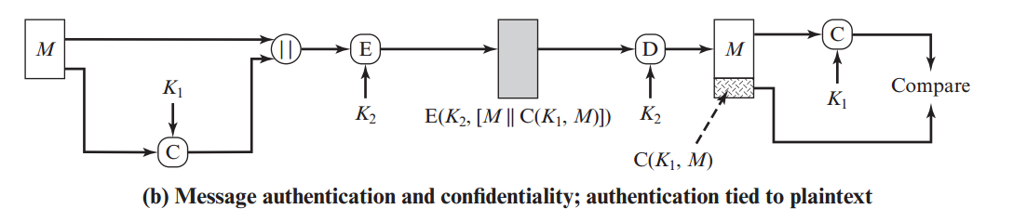
"Message authentication and confidentiality; authentication tied to plaintext"

✅ What the diagram shows
It combines:
- Authentication (via MAC)
- Confidentiality (via encryption)
using two keys: K₁ for MAC and K₂ for encryption.

🧠 Steps to Memorize for Drawing:

📤 Sender Side:
- Message = M
- Use Key K₁ with message M to create MAC = C(K₁, M)
- Combine both: [M || C(K₁, M)]
- Encrypt this combination using Key K₂ → gives: E(K₂, [M || C(K₁, M)])
- Send the encrypted block to the receiver.

📥 Receiver Side:
- Decrypt using K₂ to get [M || C(K₁, M)]
- Separate the message M and the MAC
- Recompute MAC from received M using K₁
- Compare the computed MAC with the received MAC:
  - ✅ Match → message is authentic
  - ❌ No match → message is tampered

✍️ What to Draw (for Exam):
- Left: Message M goes two ways
- Down: to MAC generator C using K₁ → gives C(K₁, M)
- Up: Combine M || C(K₁, M)
- → Into Encryption block E using key K₂
- → Encrypted output goes to the Receiver
- → Decryption block D using K₂
- → Output separates to M and C(K₁, M)
- → Compute MAC again using C and K₁
- → Compare step

💡 Shortcut to Remember:
MAC first → combine → encrypt → send → decrypt → recompute MAC → compare

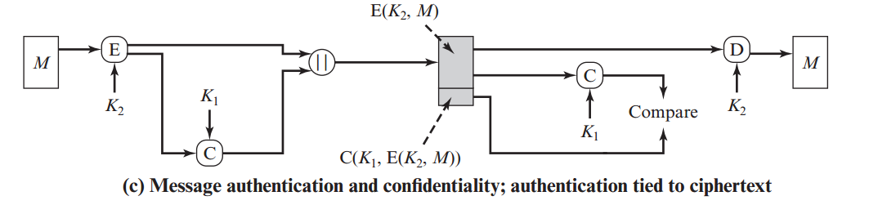

"Message authentication and confidentiality; authentication tied to ciphertext"

💡 What it shows (Summary)
In this method:
- Message M is encrypted first
- Then MAC is calculated over the ciphertext
This ensures both confidentiality and authentication of the encrypted data.

🧠 Steps to Memorize for Drawing

📤 Sender Side:
- Start with message M
- Encrypt it using key K₂ → gives E(K₂, M)
- Use key K₁ to generate MAC on the ciphertext:
→ C(K₁, E(K₂, M))
- Combine both: [E(K₂, M) || C(K₁, E(K₂, M))]
- Send both together to receiver

📥 Receiver Side:
- Receive the encrypted message and MAC
- Use K₁ to recompute MAC on the ciphertext
- Compare it with the received MAC:
  - ✅ Match → proceed to decrypt
  - ❌ No match → message is tampered
- Use K₂ to decrypt ciphertext and recover original M

✍️ What to Draw in Diagram:
- M → into E (encryption) with K₂ → gives E(K₂, M)
- E(K₂, M) goes:
  - One way → to be combined with MAC (||)
  - Other way → into MAC generator C with K₁ → gives C(K₁, E(K₂, M))
- Combine and send to receiver
- Receiver side:
  - Extract E(K₂, M) and MAC
  - Recalculate MAC with C and K₁
  - Compare
  - If OK → decrypt using D and K₂ → get back M

🔁 Shortcut to Remember:
Encrypt first → then MAC the ciphertext → send → verify MAC → decrypt

Digital Signature
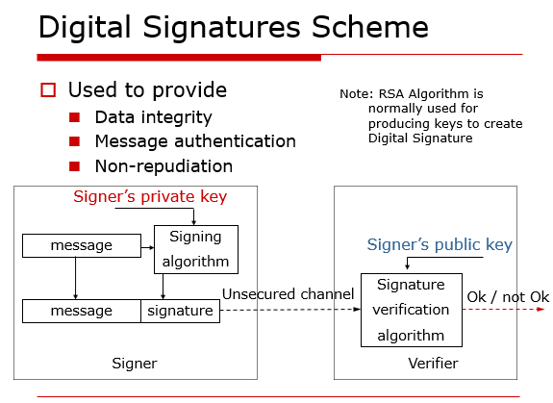

✅ Digital Signature – Short Notes

🔐 Purpose:
- Ensure Integrity, Authentication, Non-repudiation

🧑‍💻 At Sender (Signer):
- Message + Private Key → Signing Algorithm
- Output: Message + Signature

🧑‍💼 At Receiver (Verifier):
- Message + Signature + Public Key → Verification
- Output: ✅ OK / ❌ Not OK

📌 Uses:
- RSA / DSA / ECDSA
- Signature = Created with private key
- Verified using public key

💡 One-line to remember:
"Digital signature = private key to sign, public key to verify."
Let me know if you want a mnemonic or diagram shortcut too!

Hash Function
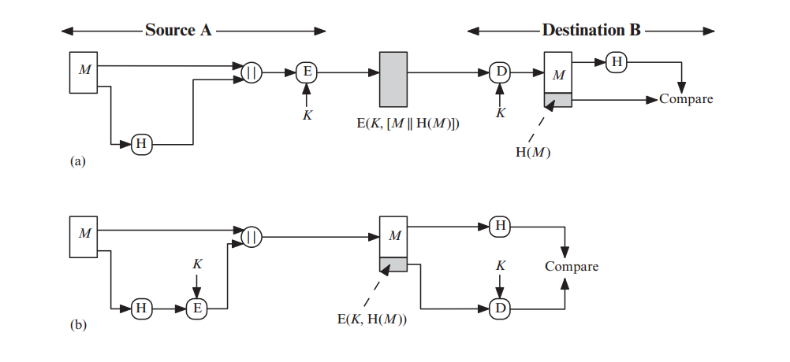
Sure! This image shows two diagrams (a) and (b) for message authentication using encryption and hashing. Here's a simple explanation you can memorize for each:

✅ Diagram (a): Encrypt-then-MAC
This is when we encrypt both the message and its hash.

🔁 Steps at Source A (Sender):
- M = Message.
- Hash the message → H(M).
- Combine the message and its hash → M || H(M).
- Encrypt the combined data using key K → E(K, M || H(M)).
- Send the encrypted data to Destination B.

🔁 Steps at Destination B (Receiver):
- Decrypt the received message using the same key K → Get M and H(M).
- Hash M again using same hash function.
- Compare received H(M) with calculated one.
- If match = Message is authentic ✅
If not = Message was tampered ❌



✅ Diagram (b): MAC-then-Encrypt
This is when we hash the message, encrypt the hash, and send it with the plain message.

🔁 Steps at Source A (Sender):
- M = Message.
- Hash the message → H(M).
- Encrypt the hash using key K → E(K, H(M)).
- Send both M and E(K, H(M)) together.

🔁 Steps at Destination B (Receiver):
- Hash the received M → H(M).
- Decrypt the encrypted hash using key K → get H(M).
- Compare both hashes.
- If match = Message is authentic ✅
If not = Message was tampered ❌

📌 Key Concepts to Remember:
- H(M) = Hash of the message.
- E(K, ...) = Encryption using key K.
- || = Concatenation (joining two things).
- Authentication is done by comparing hashes.

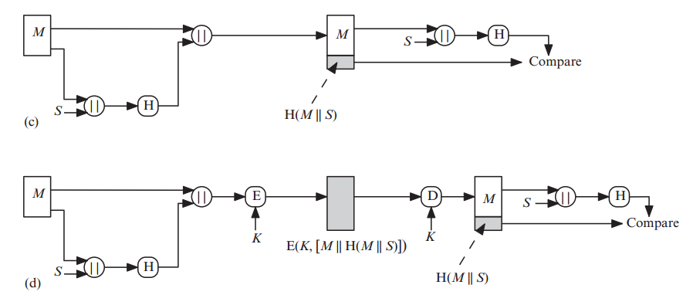

✅ Diagram (c): Secret Value Added to Message Before Hashing
This method uses a shared secret value S for authentication.

🔁 Source A (Sender):
- You have the message M.
- You also have a shared secret S.
- Combine message and secret → M || S.
- Hash it → H(M || S).
- Send both the message M and the hash H(M || S).

🔁 Destination B (Receiver):
- Receive M and H(M || S).
- Receiver also knows the secret S.
- Receiver creates the same M || S.
- Hash it again.
- Compare the two hashes.
  - If match = message is authentic ✅
  - If not = tampered ❌



✅ Diagram (d): Encrypt Message and Hash Together with Secret
This combines secret-based hashing with encryption.

🔁 Source A (Sender):
- Message is M.
- Shared secret is S.
- Make M || S, then hash → H(M || S).
- Combine message and hash → M || H(M || S).
- Encrypt all using key K → E(K, [M || H(M || S)]).
- Send the encrypted result.

🔁 Destination B (Receiver):
- Decrypt using same key K → Get M and H(M || S).
- Receiver knows S, so forms M || S, then hashes it.
- Compare the received hash with newly calculated one.
  - If match = message is authentic ✅
  - If not = tampered ❌

📌 Quick Memorization Tips:
- || means joining (concatenation).
- H(...) = hash function.
- E(...) and D(...) = Encrypt and Decrypt with key K.
- S = secret shared between sender and receiver.
- Final step always = Compare the hash to check integrity.

Let me know if you want ASCII-style or shortcut drawing ideas for exam revision!

Simplified Digital Signatures
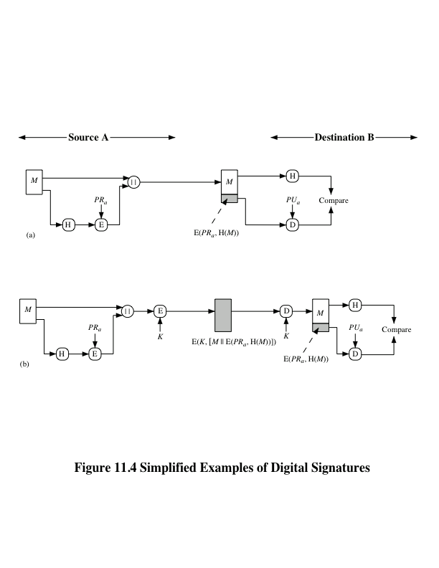

✅ Diagram (e): Secret-then-Hash (H(S || M))
This method uses a secret S that is added before the message, and then hashed.

🔁 Source A (Sender):
- You have:
  - Message M
  - Shared secret S
- Combine secret and message → S || M
- Hash this → H(S || M)
- Send M and H(S || M) to Destination B.

🔁 Destination B (Receiver):
- Receiver also knows secret S
- Combine S and received M → S || M
- Hash it → H(S || M)
- Compare with received hash.
  - If match ✅: Message is authentic
  - If not ❌: Message is tampered



✅ Diagram (f): Encrypt (M || H(S || M))
This adds encryption on top of the hash for better security.

🔁 Source A (Sender):
- You have:
  - Message M
  - Secret S
- Create S || M → Hash → H(S || M)
- Combine with message → M || H(S || M)
- Encrypt all using secret key K → E(K, [M || H(S || M)])
- Send the encrypted result.

🔁 Destination B (Receiver):
- Decrypt using same key K → Get M and H(S || M)
- Receiver also knows secret S
- Combine S and M → S || M → Hash again
- Compare the two hashes
  - If match ✅: Message is valid
  - If not ❌: Message is changed

why diagrams (e) and (f) are called "simplified examples of digital signatures" ?

✅ Here's the Simple Explanation:
Diagrams (e) and (f) simulate the behavior of digital signatures using hashing + a secret (S) and sometimes encryption (with key K) — without actually using public/private keys.
They are simplified because:

🔐 What a real digital signature does:
- Uses a private key to "sign" a message.
- Anyone with the public key can verify the message.
- Ensures:
  - Integrity (message not changed)
  - Authentication (who sent it)
  - Non-repudiation (sender cannot deny)

✅ Why (e) and (f) are simplified digital signatures:
Feature | Diagram (e) / (f) | Real Digital Signature
Uses a hash of the message | ✅ Yes, like real signatures | ✅ Yes
Uses a secret or key | ✅ Uses shared secret or symmetric key | ❌ Uses private/public key pair
Ensures integrity | ✅ Yes | ✅ Yes
Ensures authentication | ✅ Yes (with shared secret) | ✅ Yes (with private key)
Ensures non-repudiation | ❌ No (sender can deny if secret is shared) | ✅ Yes (only sender knows private key)

🧠 Conclusion (Memorize this):
"Diagrams (e) and (f) are called simplified digital signatures because they use hashing and secret keys to achieve message integrity and authentication — similar to digital signatures — but without using public-key cryptography."

